Computer Language Coding Concepts

Pointer Assignments
Pointer assignments establish a pointer-to-pointer. Instead of assigning a target object to the reference, you assign a reference to the reference. This creates a pointer-to-pointer, instead of a direct reference to an object. This allows another object reference to decide which object is eventually pointed at.

A pointer assignment always has a Reference as a source, not its Object, not its Class, but the Reference itself.

A pointer assignment is displayed with an arrow inside the diamond.

Object Pointer Assignment:
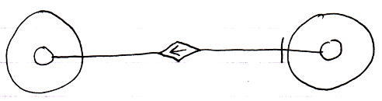
Reference Get ←
Object Set → (~= Set Object to Other Related Item)
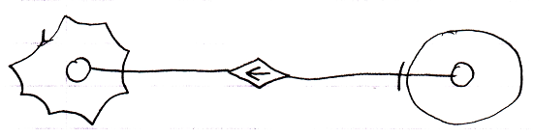
Reference Get ←
Object Set → (~= Set Object to Other Related List Item)

Reference Get ←
Object Set → (~= Set Object to Other Related List Item)

Pointer assignment also works for class assignment. You can use a reference as a class, instead using an object itself as the class:

Class Pointer Assignment:
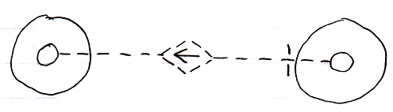
Use Reference As Class ← (~= Reference Get)
Class Set → (~= Set Class to Other Related Item)
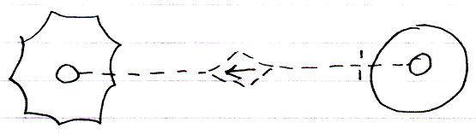
Use Reference As Class ← (~= Reference Get)
Class Set → (~= Set Class to Other Related Item)
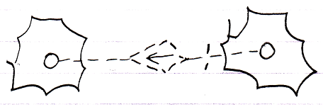
Use Reference As Class → (~= Reference Get)
Class Set → (~= Set Class to Other Related List Item)

See also: System Objects, Assignment

Author & Copyright: Jan-Joost van Zon Date: July 27, 2009 – August 31, 2009 Location: Oosterhout, The Netherlands Status: Finished

